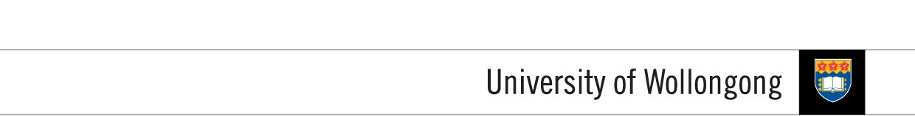

**FACULTY OF INFORMATICS**

|  |  |  |  |
| --- | --- | --- | --- |
| **SUBJECT’S INFORMATION:** | | | |
| Subject: | CSCI204 Object and Generic Programming | | |
| Session: | July 2014 | | |
| Programme / Section: | J766SENG (SE) / J766CS53 (MGD) / J766CS42 (DSS) | | |
| Lecturer: | Ms. Siti Hawa | | |
| Coursework Type  *(tick appropriate box)* | ❑ Individual Assignment ❑ Group Assignment ❑ Project  ✓Lab Task ❑ Seminar / Tutorial Paper ❑ Others | | |
| Coursework Title: | **Lab Task 9** | Coursework Percentage: | 1% |
| **ASSESSMENT CRITERIA:** | | | |
| Correctness | All programs should produce the correct result as stated in the specification. | | |
| Coding | Programs should use appropriate control structures and data structures correctly based on what have been covered in the class and stated in the specification. Necessary input validations should be done. | | |
| Readability | Appropriate comments are included. Meaningful identifiers used. Proper indentation and line spacing used. | | |
| Well formatted output | Output should be well formatted with appropriate messages displayed. Numbers are shown with appropriate precision. | | |
| **SUBMISSION:** | | | |
| All completed work should be submitted online through Moodle before or on the due date provided.  **SUBMIT AS EARLY AS POSSIBLE. YOU CAN RE-SUBMIT LATER IF NECESSARY. ONLY THE LATEST SUBMISSION WILL BE MARKED.**  **IF YOU SUBMIT YOUR ASSIGNMENT TWICE, ONE SUBMMISSION BEFORE THE DUE DATE AND ANOTHER AFTER THE DUE DATE, THEN YOU WILL BE PENALIZED FOR LATE SUBMISSON.** | | | |
| DUE DATE: | **WEEK 15** | | |
| **PENALTIES FOR LATE SUBMISSION:** | | | |
| Penalties apply to all late work, except if student academic consideration has been granted. Late submissions will attract a penalty of 25% of the assessment mark per day including the weekend. Work more than (3) days late will be awarded a mark of zero. | | | |
| **PLAGIARISM:** | | | |
| **When you submit an assessment task, you are declaring the following**   1. It is your own work and you did not collaborate with or copy from others. 2. You have read and understand your responsibilities under the University of Wollongong's policy on plagiarism. 3. You have not plagiarised from published work (including the internet). Where you have used the work from others, you have referenced it in the text and provided a reference list at the end ot the assignment.   Plagiarism will not be tolerated. Students are responsible for submitting original work for assessment, without plagiarising or cheating, abiding by the University’s policies on Plagiarism as set out in the University Handbook under University Policy Directory and in Faculty handbooks and subject guides. | | | |

**COURSEWORK SPECIFICATION**

**OBJECTIVES:**

In this lab task, you will experience how to write programs using exceptions. You are also exposed to drawing use case diagram and class diagram with associations and multiplicities.

**TASK 1:**

Write a class Counter which contains a function template CountMe. This function should take one single object, of arbitrary type, at a time. Objects of type Counter should keep a record of what types, and how many of those types, have been passed to it through the CountMe function. You may assume there won’t be more than 10 different types.

You should write a few classes, or copy from other lab exercises, to generate objects of and pass to a Counter object. You should also write a display function in the Counter class to report on the types and number of objects passed to the Counter object.

**TASK 2:**

Create a class template for a class that holds an object and the number of data elements in the object. For example, if an Employee class has two data elements, an ID number and a salary, then the class template holds the number 2 and an Employee object; if a Student class contains 12 data elements, then the class template holds 12 and a Student object. Write the code for standard input function for the object that displays a message on the screen – “You will be ask to enter X items” – where X is the number of data elements. Write a main() function that tests your template class with an integer and two programmer-defined classes.